**Project – Game Trend Analysis**

This project provides insights into gaming trends by examining factors such as platform usage, popular genres, player engagement, and regional preferences. It explores player behaviour, including playtime, subscription types, and streaming viewership, alongside game popularity and revenue generation. The data enables an in-depth analysis of evolving gaming patterns and market dynamics across various demographics

Here are some potential analyses we are going to perform:

**1. Platform Usage Analysis**

* **Market Share Comparison:**  
  Assess the share of leading game platforms (e.g., Steam, Xbox, PlayStation, Epic Games Store) to understand platform dominance and gamer preferences.
* **User Engagement Metrics:**  
  Analyse metrics such as average playtime hours, frequency of platform usage, and retention rates to evaluate engagement across gaming platforms.

**2. Genre Preference Analysis**

* **Demographic Genre Preferences:**  
  Identify which age groups prefer specific gaming genres. For example, younger gamers might prefer RPGs or strategy games, while older demographics may enjoy puzzle or simulation games.
* **Regional Genre Trends:**  
  Examine how the popularity of genres (e.g., MOBA, FPS, or educational games) varies by region, considering cultural factors and regional gaming communities.

**3. User Demographics Analysis**

* **Age Group Gaming Habits:**  
  Analyse how various age groups engage with gaming, including average playtime, most-played genres, and in-app purchase behaviour.
* **Gender-Based Preferences:**  
  Explore gender-based differences in gaming preferences, subscription types, and engagement levels.

**4. Trend Analysis Over Time**

* **Yearly Growth Patterns:**  
  Track the growth of game streaming platforms and subscriptions, noting significant increases in user base, playtime, and game viewership.
* **Impact of Technological Advancements:**  
  Assess how innovations like cloud gaming, VR/AR integration, and 5G connectivity influence gaming adoption and user experience.

**5. Device Usage Analysis**

* **Device Preference Trends:**  
  Analyse which devices (e.g., PCs, smartphones, consoles, tablets) are most commonly used for gaming and how this differs by demographics.
* **Impact of Device Integration:**  
  Evaluate how cross-platform gaming and device compatibility (e.g., smart TVs, handheld consoles) impact user engagement and gaming habits.

**6. Subscription and Revenue Analysis**

* **Subscription Growth:**  
  Examine trends in free vs. premium subscriptions and in-app purchases to understand monetization patterns.
* **Revenue Streams:**  
  Analyse the contribution of different revenue sources, such as subscription fees, advertisements, in-game purchases, and partnerships.

**7. Social Media Influence Analysis**

* **Social Media Impact:**  
  Study how platforms like Twitch, YouTube Gaming, and Facebook Gaming influence game popularity, such as boosting viewership and creating viral game trends.
* **User-Generated Content:**  
  Analyse the role of content like live streams, reviews, and custom mods in driving engagement and game discovery.

**Dataset Overview:**

CREATE TABLE game_dataset (

year INT NOT NULL,

month VARCHAR(20) NOT NULL,

platform VARCHAR(65) NOT NULL,

genre VARCHAR(65) NOT NULL,

game_type VARCHAR(45) NOT NULL,

age_group_13_18 INT NOT NULL,

age_group_19_25 INT NOT NULL,

age_group_26_35 INT NOT NULL,

age_group_36_45 INT NOT NULL,

age_group_46_plus INT NOT NULL,

male_percentage INT NOT NULL,

female_percentage INT NOT NULL,

device_type VARCHAR(45) NOT NULL,

monthly_active_users INT NOT NULL,

playtime_hours INT NOT NULL,

revenue_usd INT NOT NULL,

arpu_usd FLOAT NOT NULL,

paid_subscribers_percentage INT NOT NULL,

free_subscribers_percentage INT NOT NULL,

likes INT NOT NULL,

shares INT NOT NULL,

comments INT NOT NULL,

peak_gaming_hours_utc VARCHAR(45) NOT NULL,

churn_rate_percentage INT NOT NULL

);

**Database Connectivity:**

**To perform the analysis, we'll establish a connection to the MySQL database containing the ecommerce data. We'll use the appropriate Python libraries, such as pandas and mysql, to fetch and manipulate the data directly from the database.**

**import** mysql.connector

**import** pandas **as** pd

*# Connect to MySQL*

connection **=** mysql**.**connector**.**connect(

host**=**"localhost", *# Replace with your host (e.g., "127.0.0.1")*

user**=**"root", *# Your MySQL username*

password**=**"1234", *# Your MySQL password*

database**=**"project" *# Optional: specify database to connect to*

)

*# Check connection*

**if** connection**.**is_connected():

print("Connected to MySQL!")

Connected to MySQL!

In [18]:

*#create cursor object to execute sql queries*

cursor **=** connection**.**cursor()

*# Query the data from walmart data sale*

cursor**.**execute("SELECT * FROM dataset")

*#After fetching data from the database we are storing it into Pandas DataFrame*

dataset **=** pd**.**DataFrame(cursor**.**fetchall(), columns**=**[desc[0] **for** desc **in** cursor**.**description])

print(dataset**.**head(5))

Output:

**Description:**

customer_data = pd.DataFrame(cursor.fetchall(), columns=[desc[0] for desc in cursor.description])

**cursor.fetchall():**

This part of the code fetches all the rows from the result set obtained from a database query using the cursor object. The fetchall() method retrieves all the rows as a list of tuples.

**columns**=[desc[0] for desc in cursor.description]: This part creates a list of column names for the DataFrame. It uses a list comprehension to iterate over the cursor.description, which is a list of 7-item tuples describing the columns in the result set. The [desc[0] for desc in cursor.description] extracts the rst element (column name) from each tuple in the cursor.description and creates a list of column names.

**pd.DataFrame(...):** This part creates a Pandas DataFrame using the pd.DataFrame() constructor. It takes the fetched data (result of the query) and the list of column names as arguments. The DataFrame is assigned to the variable customer_data.

**Data Cleaning:**

Before proceeding with the analysis, let's perform some basic data cleaning:

* Check for missing values in each table.
* Ensure data types are appropriate for each column.
* Handle any outliers or inconsistencies.

**Exploratory Data Analysis (EDA) and Visualization:**

**1.Which region has the highest number of players in 2023**

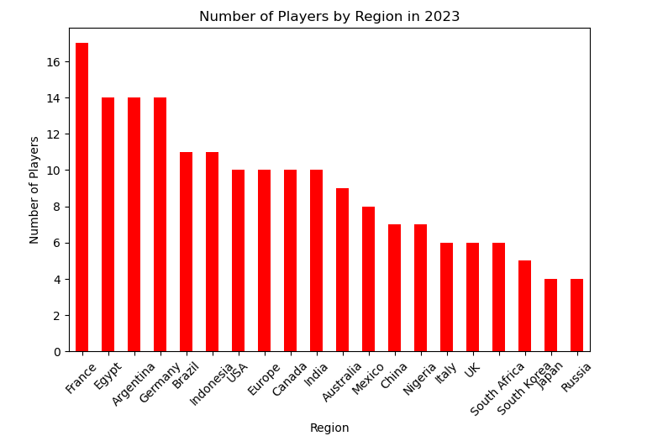

**2. What are the top 3 most popular game genres across all regions**

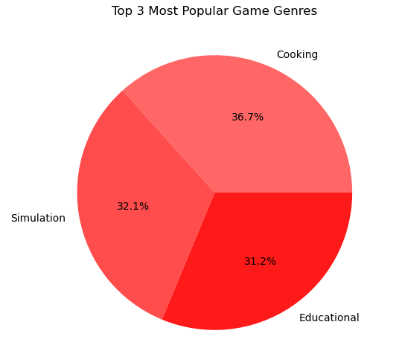

**3.What is the trend in average monthly revenue per player from 2019 to 2024**

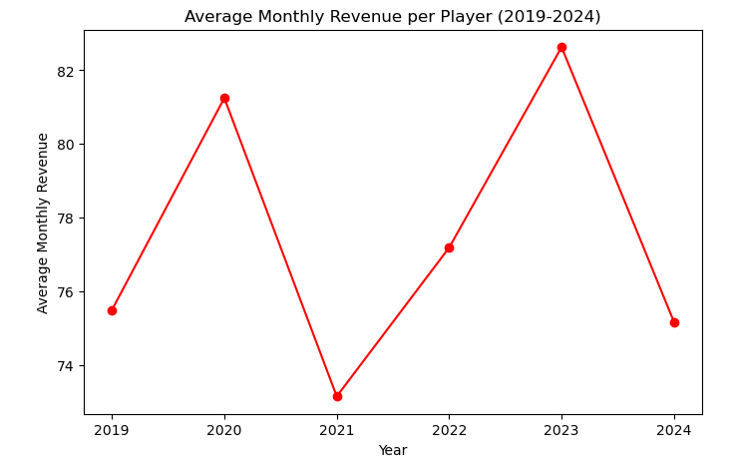

**4. Highest Game Popularity Score by Age Group**

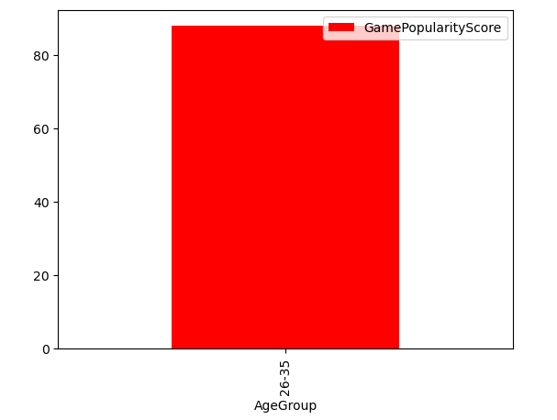

**5. What is the growth in stream viewership for Twitch over the years**

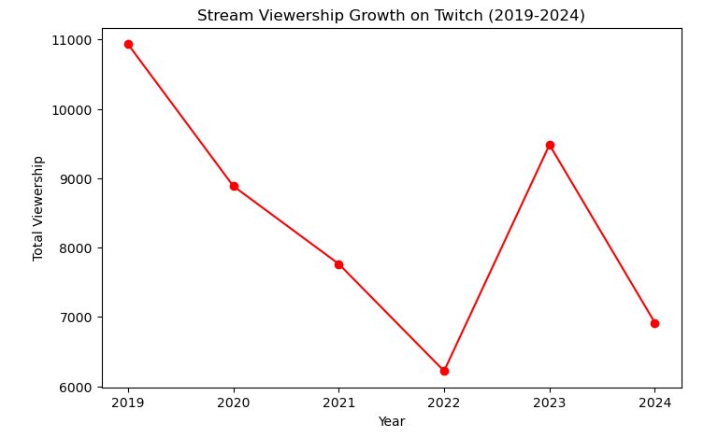

**6.Which region has the highest game popularity score for FPS games**

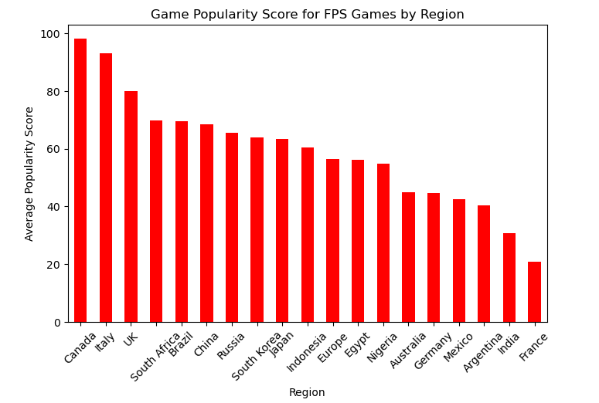

**7.What percentage of players have premium subscriptions by region**

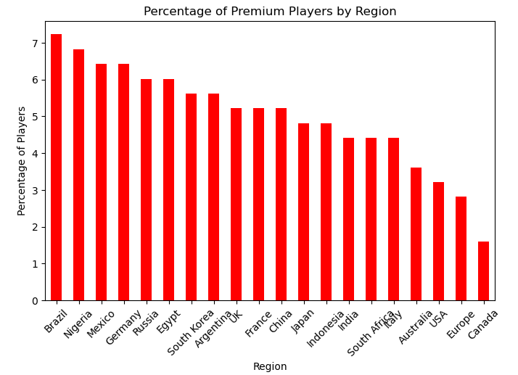

**8.What is the age distribution of players in MOBA game**

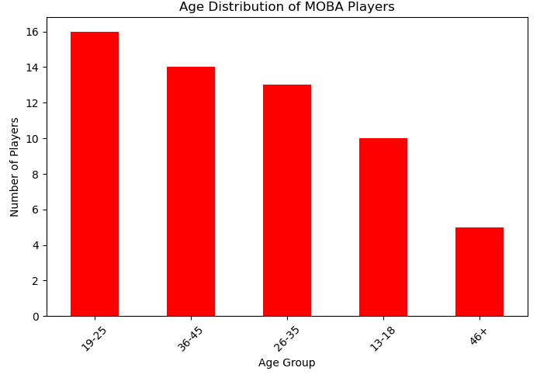

**9 .What are the revenue patterns for in-app purchases vs. premium subscriptions**

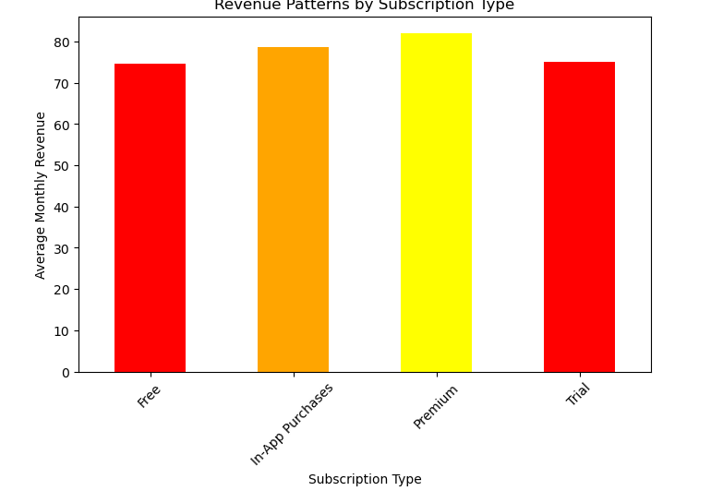

**10. Platform with the Highest Monthly Revenue**

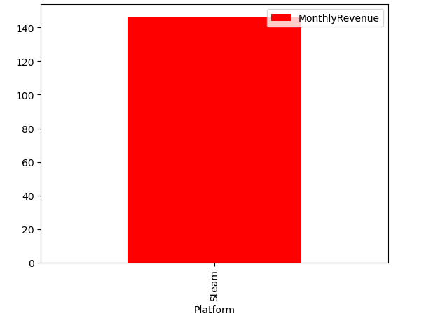

**Conclusion:**

The analysis highlights key trends in the gaming market: premium subscriptions and VR platforms lead in revenue, while trial subscriptions and PC platforms lag. Horror and strategy games are the most popular, with simulation games at the bottom. Canada tops FPS game popularity, while France ranks lowest. Brazil has the highest percentage of premium players, and Canada the lowest. The 19-25 age group dominates MOBA players, while the 46+ group is the smallest. These insights reveal strengths and growth opportunities in the gaming industry.